Outdoor Ethic Guide Course Appendix
(This is just a sample you can come up with or adapt any ideas you want)

Appendix A
Outdoor Code and samples of displays
Appendix B
Mission statements
Appendix C
History of BSA Outdoor Ethics
Appendix D
TREAD Values Game
Appendix E
Outdoor Code Activities
Appendix F
Leave No Trace Activity
Appendix G
TREAD Lightly! Activities
Appendix H
Land Ethics Pamphlet
Appendix I
Stewardship activities
Appendix J
Outdoor Ethics Awards
Appendix K
Outdoor Ethics Summary Handout
Appendix L
Web of Life
Evaluation

Appendix A: The Outdoor Code
The image below can be used in a poster, can be turned into a matching game, or left blank below the key points for participants to fill in.

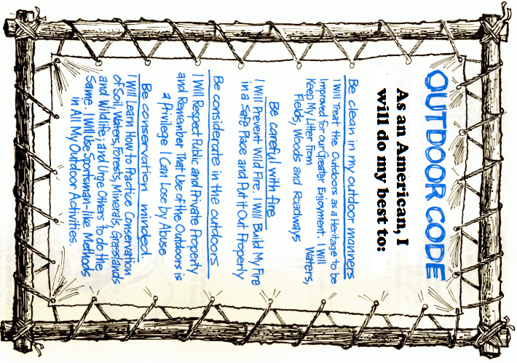

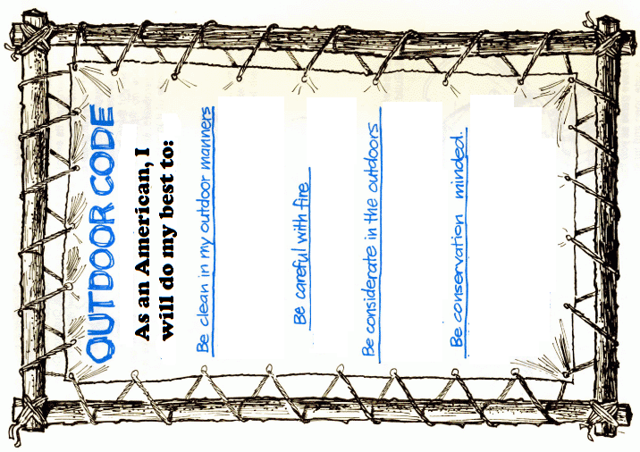
Sample Outdoor Ethics Displays
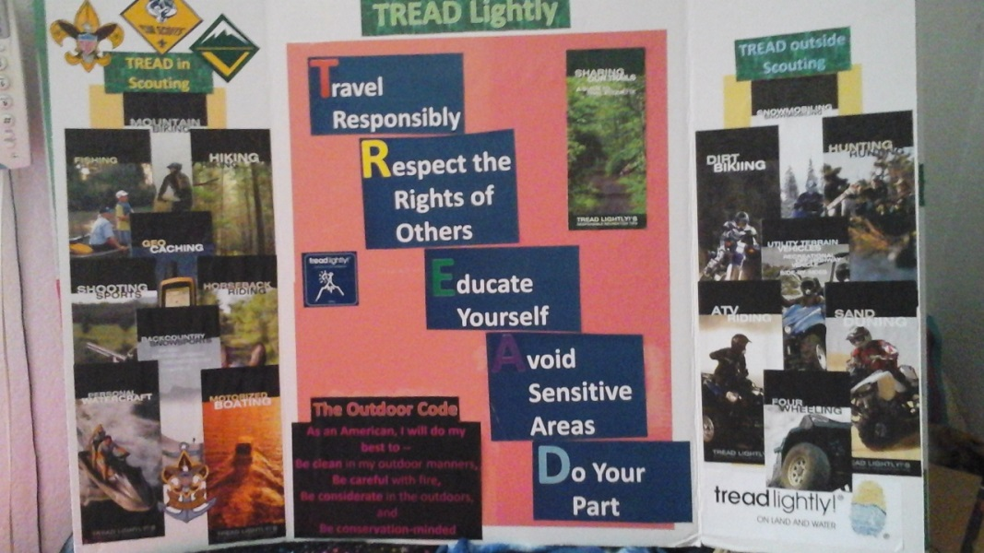
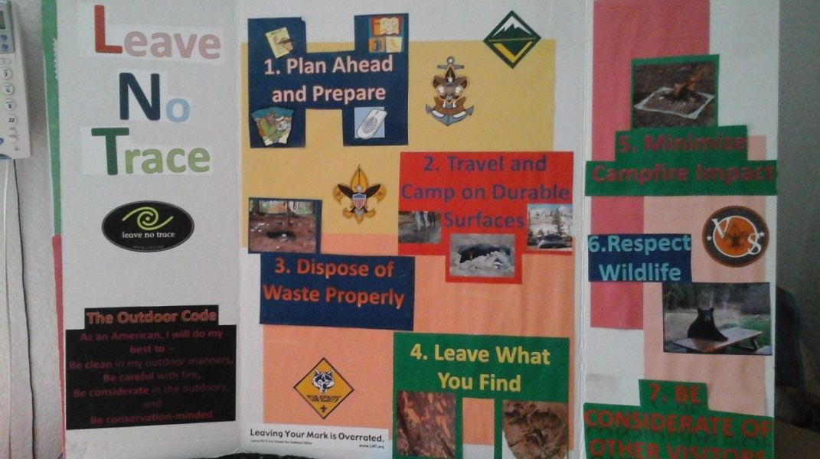
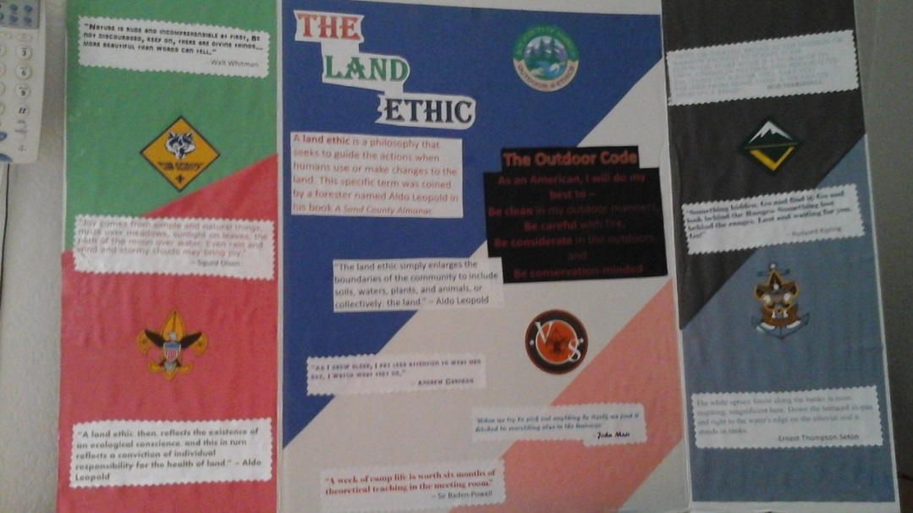
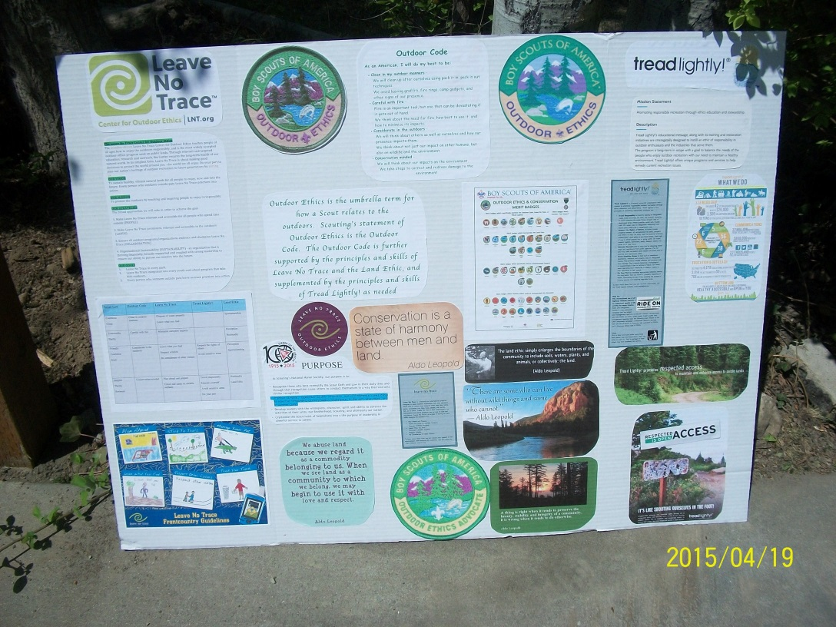
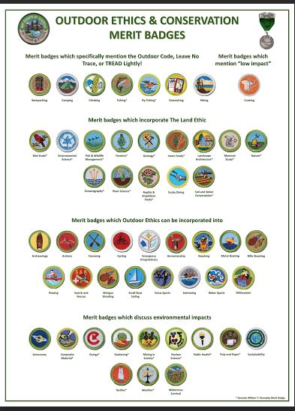
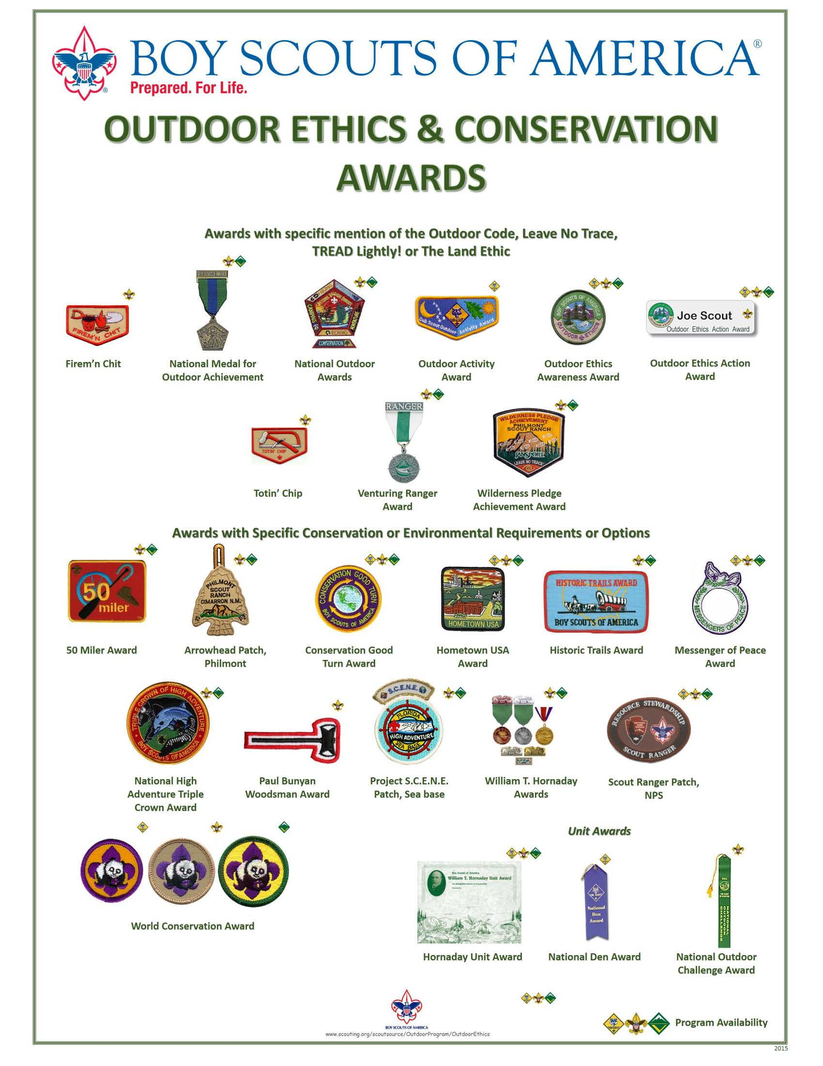

Appendix B: Mission Statements

Boy Scouts of America
The mission of the Boy Scouts of America is to prepare young people to make ethical and moral choices over their lifetimes by instilling in them the values of the Scout Oath and Law.

Leave No Trace
The purpose of Leave No Trace is to protect the outdoors by teaching and inspiring people to enjoy it responsibly.

Tread Lightly
The purpose of TREAD Lightly! is to promote responsible recreation through education.

Appendix C
History of Outdoor Code and Outdoor Ethics in Scouting
In the late 1800s and early 1900s, United States embraces the “Conservation Movement”
  - 1871 – Fish & Wildlife Service created
  - 1872 – First National Park (Yellowstone)/ General Mining Law Past
  - 1877 – Desert Land Act passed
  - 1891 – First National Forest
  - 1905 – U.S. Forest Service established
  - 1910- Boy Scouts of America is formed
  - 1910 – The Great Fire
  - 1911 - Handbook for Boys
  - In 1917, the William T. Hornaday established the Wildlife Protection Medal, awarded to individuals for protecting wildlife.
  - 1936 – Boy Scouts take over the Wildlife Protection Medal and rename it the Hornaday Award.
  - 1944 - Scouting adopted the “Wilderness Code of Conduct” for use of backcountry
  - 1944 – Smokey Bear is introduced by the US Forest Service to introduce fire safety
  - 1946 – Bureau of Land Management is formed
  - 1948 – Boy Scouts adopts the Outdoor Code
  - 1949 – Aldo Leopold publishes “The Sand County Almanac”
  - 1952 – Wildlife MB; Soil Management MB
  - 1954 – Conservation Good Turn
  - 1960’s – Forest Service creates “Leave No Trace”
  - 1970 – Honda introduces the 3-wheel ATV / Used in Bond movie “Diamonds are Forever”
  - 1971 – Woodsey Owl is introduced by the US Forest Service to promote environmental protections
  - 1982 – Suzuki introduces the 4-wheel ATV
  - 1985- “Tread Lightly” created by the Forest Service
  - 1990 – TREAD Lightly! becomes a non-profit organization
  - 1993 – Leave No Trace Center is established
  - 2008 – TREAD Lightly! Awarded a Hornaday Gold Award by BSA
  - 2012 – Leave No Trace Task Force becomes Outdoor Ethics Task Force and adopts a new logo

Appendix D: TREAD Values Game
Objectives:
- Participants will experience and acknowledge value differences within a group.
- Through discussion participants will recognize the role values play in Outdoor Ethics and as a motivator of behavior.
Duration:
No more than 5 minutes
Setting: Indoors or outdoors
Materials Needed: Choice pair cards (For a full set or to enlarge download and print from www.treadlightly.org/files/page_text/Values Game.pdf)

In Brief:
Participates will physically acknowledge the type of items or experiences they value and discuss why. Opportunities will arise to discuss respecting differing values, finding common ground, and the role values can play when discussing Outdoor Ethics.

How to play:
Step 1: Ask participants to stand and lead them to an open area for the activity.
Step 2: Create an imaginary line (for example, each side of the room). Each side of the line represents one preference between two things.
Although someone may say they are indifferent, they should choose.
Step 3: Provide the pairs to choose between, one pair at a time.
Specify which side of the line represents each item in the pair, and ask the group to choose which they personally prefer and move to the side of the line that represents their choice.
Step 4: After each choice, have one volunteer from each side say why he/she chose that side.
Instruct the members of the other group to say, “Isn’t that interesting?”, rather than making negative comments.
Step 5: Discuss the group’s observations about the activity.

Learning points:
•We all have different preferences; we all value things differently.
•We must respect those differences (that is the purpose of “Isn’t that interesting?” –to avoid questioning the other’s choice).
•There are some values that most of us agree on even though we differ on many others. We should start from our common ground

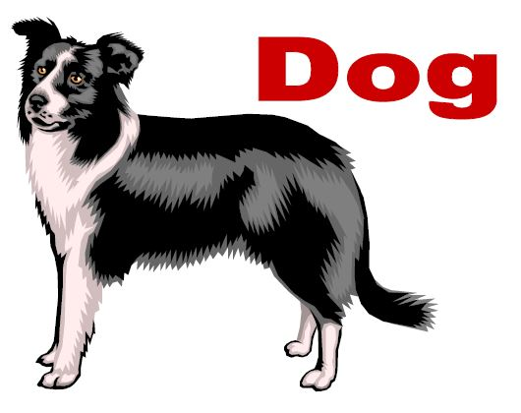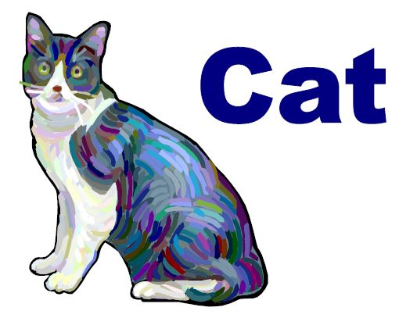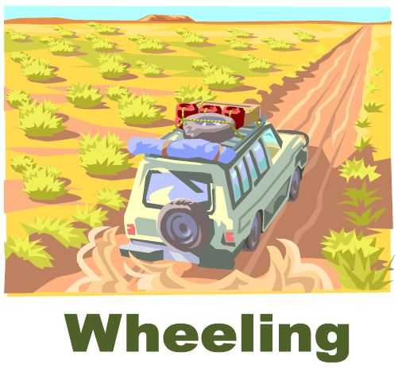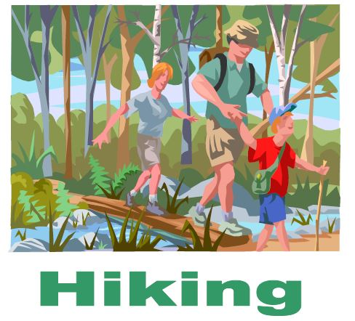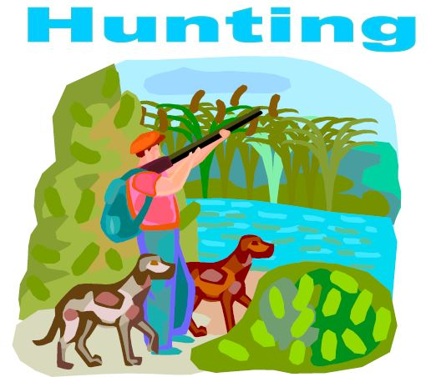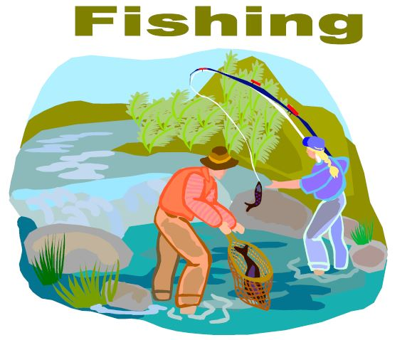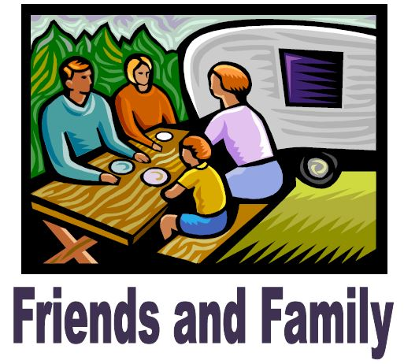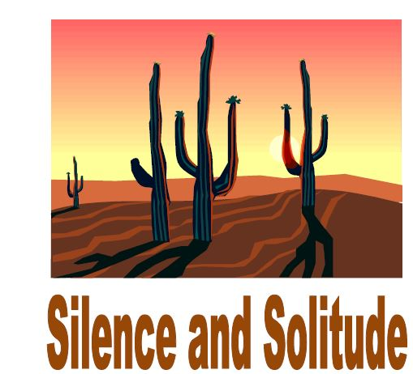
Appendix E: Outdoor Code Activity
Create a matching game using the chart below. Using the Outdoor code as the guide or top of the chart.
Scout Law | Outdoor Code | Leave No Trace | Tread Lightly! | Land Ethic
Courteous  Clean | Clean in outdoor manners | Dispose of waste properly  Leave what you find |  | Sportsmanship
Trustworthy  Thrifty | Careful with fire | Minimize campfire impacts |  | Perception  Husbandry
Friendly  Courteous  Kind | Considerate in the outdoors | -Leave what you find  -Respect wildlife  -Be considerate of other visitors | -Respect the rights of others  -Avoid sensitive areas | Perception  Sportsmanship
Helpful  Thrifty  Reverent | Conservation-minded | Plan ahead and prepare  Travel and camp on durable surfaces | -Travel responsibly  -Educate yourself  -Avoid sensitive areas  -Do your part | Husbandry  Land Ethic

Participants put the pieces of the Scout Law, Leave No Trace, Tread Lightly!, and Land Ethic into the appropriate category. Review the answers and see how many they got right.
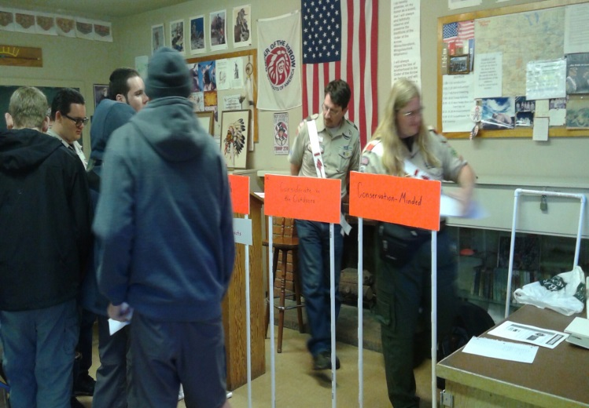

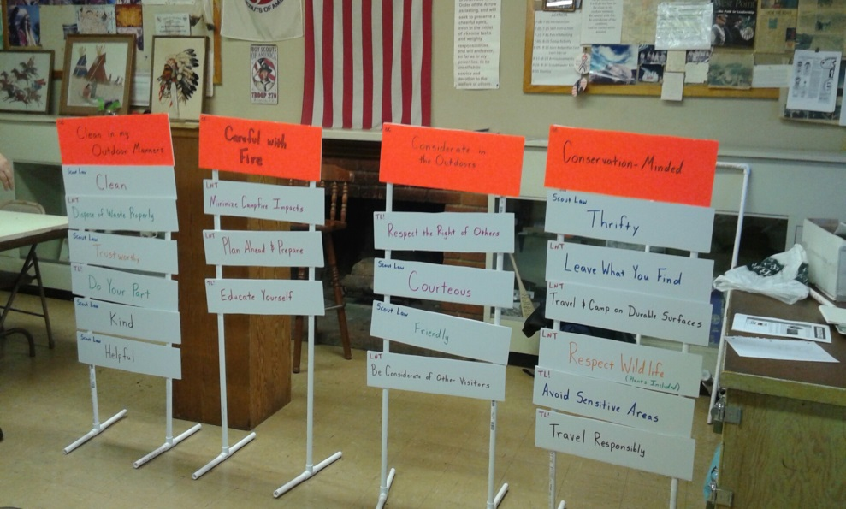

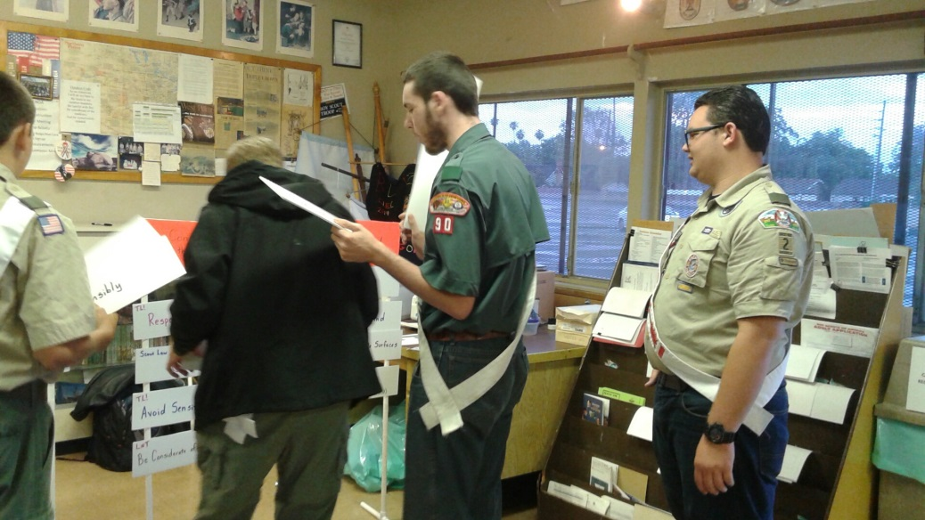
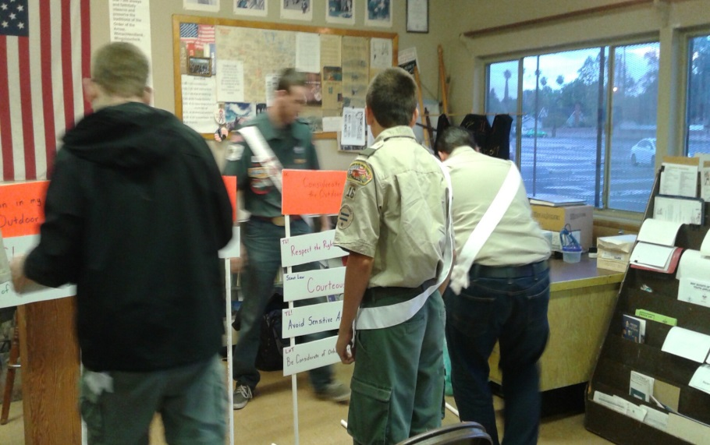

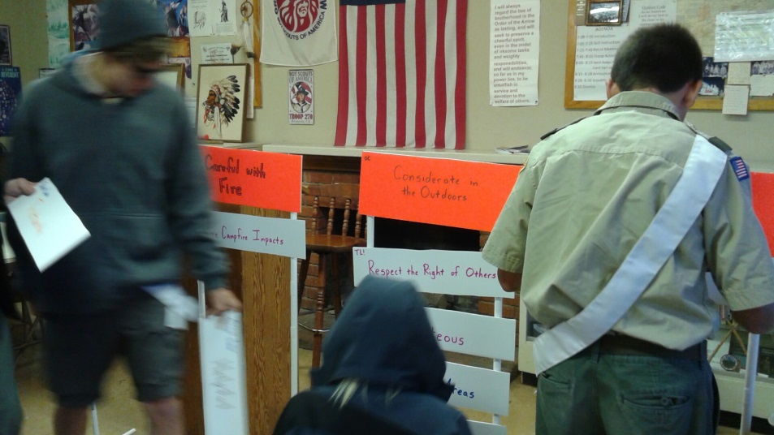
Special Thanks to the Wanakik Chapter of Cahuilla Lodge #127 for demonstrating the game.

Appendix F: Leave No Trace Activities

Activity 1

Lead an ethics debate on Leave No Trace values
By Mark Ray
Illustrations by Mike Byers
From the May-June 2012 issue of Scouting magazine
Read our Leader’s Guide to Leave No Trace and learn how—and why—you should teach Scouts the importance of Leave No Trace values.

THE SEVEN PRINCIPLES of Leave No Trace (below) are intentionally open-ended—some might say vague—which makes them work well in settings such as city parks, Scout camps, national forests, and wilderness areas. Literal-minded Scouts, though, may have trouble applying the principles in situations where the right action to take isn’t always clear. An example follows.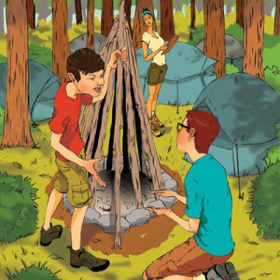
The Dilemma
Many teenagers think of spring break as a time to head to the nearest beach or theme park. Not the members of Troop 412. Each March they travel to the Ouachita Mountains near the Oklahoma-Arkansas border for five days of backpacking. During most years, the Scouts enjoy seasonably warm weather. But this year is different. The nights are cold, the trails are a muddy mess, and the Scouts only packed shorts and T-shirts.
Tuesday’s hike takes the group along—and occasionally across—the Kiamichi River. In keeping with Leave No Trace principles, the Scouts stay on the established trail, even though it’s little more than thick, clinging, ankle-deep mud. To top things off, rain starts falling in late afternoon. As the sun sets, they drag themselves to a campsite, tired, hungry, and soaked to the skin.
As most of the Scouts collapse onto their packs, the patrol leaders’ council huddles to discuss plans for setting up camp. Senior Patrol Leader Jon Albertson suggests pitching tents and getting the camp stoves going for dinner, but Nate Blackledge, patrol leader of the Rattlesnakes, disagrees. He has already started building a giant campfire so all the Scouts can warm up and get their boots and clothes dry.
Jon shakes his head, pointing out that Leave No Trace recommends that campfires—if they’re built at all—be small. He says to Nate, “Look, dude, you didn’t want to stay on the trail this morning. You threw your orange peel on the ground after lunch. What part of ‘Leave No Trace’ don’t you understand?”
“The part that says we’re supposed to freeze to death, I guess,” Nate snaps.
What should the PLC decide to do?
For Discussion
To help Scouts or Venturers explore this dilemma, discuss these questions together:
Is Jon correctly interpreting the fifth principle of Leave No Trace, which says to “minimize campfire impacts”? If not, how is he wrong?
Does Nate have a valid argument about the need to build a big campfire? Why or why not?
Does the fact that Nate was violating other Leave No Trace principles earlier in the day weaken his argument? Why or why not?
The troop’s campsite is in a national forest. Does that setting make a difference in what the PLC decides? Why or why not?
What if the setting were a Scout camp? A state park? Private property (used with permission)?
The first principle of Leave No Trace is “Plan ahead and prepare.” Could the troop have avoided this situation if they’d been better prepared? Explain.
When you have to choose between two positive values (in this case, Leave No Trace or the comfort of the troop members), how do you choose?
Next Steps
Now, take the situation further. Invite your Scouts or Venturers to role-play the PLC’s discussion and come to a decision about building the campfire. When they’ve reached a decision, discuss these questions:
How does your decision support Jon’s concern about Leave No Trace?
How does your decision support Nate’s concern about the Scouts’ well-being?
What did you learn from this dilemma?

Leave No Trace Guidelines
1. Plan ahead and prepare.
2. Travel and camp on durable surfaces.
3. Dispose of waste properly.
4. Leave what you find.
5. Minimize campfire impact.
6. Respect wildlife.
7. Be considerate of other visitors.

Activity 2

A Winning Hand
Card game can help you turn Leave No Trace principles into action.
Illustration by Tim Tomkinson
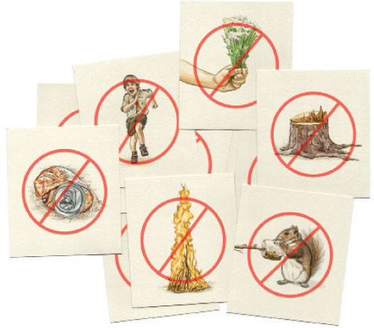
WHEN SCOUTS GO CAMPING, they build muscles and memories. With a little guidance, they can build something else, too: a stronger sense of outdoor ethics.

Guidelines for Cub Scouts
- Plan ahead.
- Stick to trails.
- Manage your pet.
- Leave what you find.
- Respect other visitors.
- Trash your trash.
In recent years, Leave No Trace principles have become entrenched in Scouting. Cub Scouts and Boy Scouts now earn Leave No Trace Awards, Leave No Trace requirements appear in both Boy Scout and Venturing advancement requirements, and many Scouters have become Leave No Trace Master Educators or Trainers. As a result, many boys and adult leaders can recite the seven principles of Leave No Trace as easily as they can recite the 12 points of the Scout Law.
Leave No Trace, though, is about more than just awareness. It’s about action. And you have a great way to bridge the gap with your Scouts. Play an outdoor ethics card game, adapted from the BSA’s Leave No Trace Trainer Course Manual, at your meeting place or on an outing. It’s designed to help Scouts develop a personal sense of outdoor ethics by teaching them to consider the impact of their actions.
If you’re playing the game with Boy Scouts or Venturers, distribute index cards and pens or pencils to the group. Give the players a few minutes to record actions humans take that affect the environment. Each action goes on a separate card. Aim to generate a few dozen cards with ideas.
For Cub Scouts, create a set of 20 or more cards ahead of time that show actions humans take that affect the environment. Examples: straying from established trails, picking wildflowers, building large campfires, running and yelling, feeding wild animals, littering, urinating near streams, and cutting down trees.

The 7 Principles
- Plan ahead and prepare.
- Travel and camp on durable surfaces.
- Dispose of waste properly.
- Leave what you find.
- Minimize campfire impacts.
- Respect wildlife.
- Be considerate of other visitors.
To start, collect all of the cards and pull two from the stack at random. Read the impacts listed aloud and have the players decide which is more disgusting or distasteful, setting that card aside (no need to take a vote; just get a consensus of which action is worse). Repeat with additional pairs of cards until you’ve worked your way through the deck.
Play a second round, this time using only the cards you set aside in the first round. Follow the same process, again setting aside the cards most players selected. With Boy Scouts and Venturers, challenge players to explain why they chose each impact before finalizing the selections. You might find that one player’s logic will sway the choice of other players.
Play a third round with the set of cards set aside in round two. Again, challenge Scouts and Venturers to justify their choices.
After the game, discuss some of these questions, choosing the ones that seem most appropriate for your Scouts’ age:
- We’ve talked about some distasteful actions. Why do you think people take those actions? What would be better alternatives to each one of them?
- Do you think anybody from our pack/troop/crew committed any of those actions on this outing (or on our most recent outing)?
- In which ways did we do a good job of following Leave No Trace principles on this outing (or on our most recent outing)?
- On a scale of 1 to 10, how would you rate our behavior on this outing (or on our most recent outing)? How would you rate your own behavior?
- Leave No Trace principles are guidelines, not rules. What’s the difference? Why are the principles not presented as rules?
- Do you think one of the seven Leave No Trace principles is more important than the others? If so, which one and why?
- Do you think one of the seven Leave No Trace principles is less important than the others? If so, which one and why?
Some argue that the best way to Leave No Trace would be to stay out of natural areas altogether. Do you agree or disagree? Why?

Activity 3:
www.NevadaOutdoorSchool.org
LNT_quickies (It is 30 pages long. Download it if you want it all)
Camp Ohno!
Nutshell: Teach participants Leave No Trace principles by showing them a first-hand example of a high-impact camp-
site. This works well for stationed events where participants rotate through various educational stations.

Objective: Participants will be able to list at least four of the seven principles and one way to follow each of them.

Materials: Tent; litter; fake rocks and fire; washing tub, dishes, and fake dish soap; blue towel to represent water (if not by actual water); fake flowers; fake axe; Inspiration Point sign (written on); boom box; food scraps; LNT principle signs

Time Considerations: Can be adjusted for station lengths from 15 to 30 minutes

Directions: Have Camp Ohno set up before participants arrive. The list below matches the high-impacts with corresponding LNT principles and the information in parenthesis is what should be done. When participants arrive have the music playing loudly. Turn it off and welcome them to Camp Ohno, tell them to have a look around for a few minutes and try to spot what is done wrong, then you will come back together and discuss it.

- Know Before You Go – Don’t put rain fly on tent (it could rain, bring just in case)
- Choose the Right Path - tent set up too close to water (should be 200 ft away)
- Trash Your Trash - litter (put in trash can), washing tub in creek/lake (should be 200 ft away)
- Leave What You Find - picked flower (no pollinate to make more if not there)
- Be Careful With Fire - if there is a fire ring already set up your fake fire elsewhere (use existing fire ring), litter in fire
- (can be hazardous, paper products float away and start forest fire), axe in tree (use dead and down wood)
- Respect Wildlife - food scraps on ground (never feed wildlife, it damages their health, alters natural behaviors, ex-
- poses them to predators and other dangers )
- Be Kind to Others Visitors - playing music loud (low volume, headphones, or leave at home)

Have fun and come up with more ways to stump them. Put a raccoon puppet in a cooler, put an empty dog leash on the side of the tent, put fake pooh (yes, I wrote pooh) in the campsite…. Stick a trowel with toilet paper right outside the door. Have the wrong map for the area you’re in. Have fun!!!!
Appendix G: Tread Lightly! Activities
treadlightly.org/education-trunk has lots of ideas
Beach Ball

Purpose:
Help participants understand the importance of applying minimum impact principles to mechanized and motorized recreation.

Supplies:
One blow up beach ball with questions related to this principle. Write the questions listed below on the ball. Write them going in different directions so it is easy to determine where a question starts and ends. Be sure to include the number so you can refer to the answer sheet if necessary. Up to 60 questions will fit on a 24" beach ball. Develop more questions that are more site specific for your area.

Directions:
“I am going to toss this ball out to you. I would like you to keep batting it around until I say STOP. The one holding the ball will tell me the number and read the question by their right thumb. You will then answer the question and we will discuss it. Okay, here we go.

Toss the ball out to the participants. Stop it about every 4 to 5 hits and go through the question and answer process. You have the answers to the questions listed below for reference.

1: What is the difference between LNT and Tread Lightly?
Tread Lightly applies to mechanized and motorized recreation and LNT applies to other recreation.

2: List 5 mechanized or motorized recreational vehicles that can benefit from Tread Lightly:
Motor Boats
Snowmobiles
All Terrain Vehicles
4 Wheel Trucks and/or SUV’s
Dirt Bikes

3: Complete this sentence: Drive , not obstacles to avoid the trail.
over around widening

4: When riding an ATV on slick trails, moderate the and use the to gain maximum
throttle clutch

with minimum .
traction tailspin

5: When riding an ATV yield the right of way to those you or traveling .
passing uphill

6: When riding an ATV yield the right of way to , , and .
mountain bikers hikers horses

7: When riding an ATV cross only at points or where the crosses the .
stream

streams designated fording trail

8: When riding a snowmobile always check the and conditions.
weather forecast avalanche

9: Whenever riding a snowmobile or ATV we should always obtain a and determine
map which areas

to your type of recreation.
are open

10. When riding a snowmobile you should cross roadways at a % angle.
90

11: When riding a snowmobile ride , keep to the and on the when the
single file right pass left

trail is clear.

12: When riding on private property always before the ride from the property owner.
obtain permission

13: When riding an ATV or snowmobile lean the turn to enhance and .
into stability maneuverability

14: All mechanized and motorized recreational vehicles should be after every trip outdoors to
washed

prevent the of .
spread invasive species

15: High speeds in a boat near leads to and cause .
shorelines large wakes shoreline erosion

16: Always launch a boat at a .
designated boat ramp

17: Backing a vehicle on a riverbank or lakeshore can the area and leads to .
damage erosion

18: When boating never a wake.
jump

19: Contact area land managers for area and .
closures restrictions

20: Responsible recreation will recreational opportunities in the future.
Protect
Appendix H: Land Ethic Handout
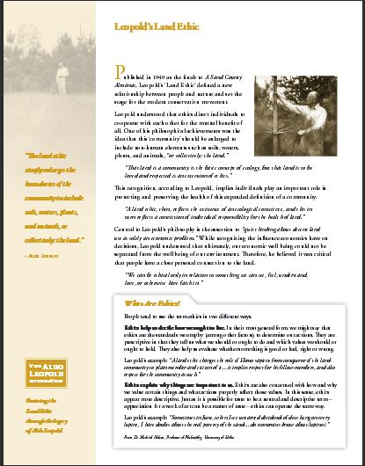
Downloadable from http://www.aldoleopold.org/AldoLeopold/LandEthic.pdf
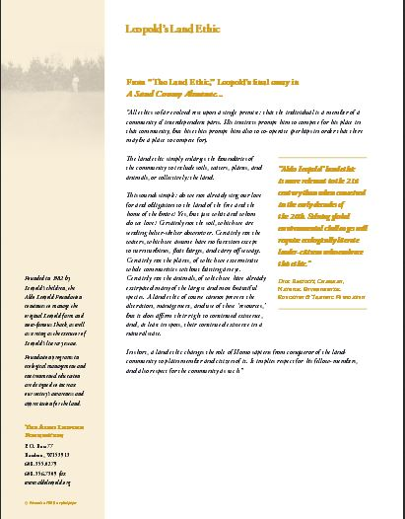
Appendix I: Stewardship Activity
Population Connection: Commons
This activity was originally developed by Hard Bargain Farm Environmental Center, Accokeek, MD.
This activity goes fast once set up. All materials are disposed of by pouring through a coffee filter over the sink. Water goes down the drain and all the stuff gets tossed with the filter into the trash.
Materials:
• A clear gallon jar of water
• A plastic film canister for each participant, with label taped to it (baby food jars work also)
• Optional—Plastic fish toy
• Large strainer or colander with a coffee filter inside
• Canister ingredients (all are safe for students to handle):
Dry Elements
• Trees: Dry, crumbled leaves
• Building site: 1/2 tsp. dry clay soil (not sand)
• Farmer:1/4 tsp. baking soda
• Family picnic: Assorted litter (small shreds of paper, pieces of plastic grocery bags, etc.)
• People fishing: Tangle of fishing line (or dental floss)
Wet Elements
• Barnyard: 1/2 tsp. brown liquid, a few crystals of instant coffee mixed with water or food color mix
• Factory: 1/4 tsp. of diluted red food coloring
• Cars/Drivers: 1/4 tsp. of vegetable oil
• Washing the car: 1/2 canis ter of soapy water
• Motorboat: 1/4 tsp. vegetable oil
Procedure:
1. Prepare and label the film canisters as described in the materials section, enough for each participant to have at least one canister.

2. Fill a clear, wide-mouthed gallon container with water nearly to the top. Place it near where you will be reading the story.

3. Give one labeled canister to each participant.

4. Explain that you will tell a story about the river, (insert the name of a river in
your area, if you wish) and that each of the participants will play a part in the story. When they hear the name of the matching canister, open it, and empty its contents into the container, which represents the river.

5. Read the story that follows. Pause after questions within the story to give the students time to think and respond.
6. After finishing the activity, use the strainer or colander to take the solids out of the water before you dispose of it.

The Story:
There was a time many years ago when our land was very wild. This was a time before roads and cars. Only a small number of people lived here then. These native people depended on nature for many of the things they needed to survive, but they lived simply and didn’t change the natural surroundings too much. The people hunted in the forests, found food in the swamps, and caught fish in the river. [Insert the name of a local river.]

The beautiful and sparkling river was home to fish and other wildlife.

Eventually, more people traveled to this land from across the ocean. They found rich soil for farming, forests full of wildlife, and a river that provided plenty of food and water. It was a perfect place to live.

The river has changed a lot since that time long ago. This is the story of those changes.

Listen for the name of what’s pictured on your slip of paper. When you hear your picture named, walk up water container and dump what’s inside into the river.

[NOTE: Be sure to stand to the side, so everyone can see the bowl.]

Years went by, and once in a while there were big storms. Strong winds whipped through the TREES and blew leaves into the water.

More and more people moved to the area. Gradually, a city grew up around the river. People drained swamps and cut down forests to build houses, schools, churches, stores, roads, hospitals and many other buildings. Rains washed loose soil from these BUILDING SITES into the river.

At first, the city was small. Upstream, FARMERS planted crops to feed all the people as the city grew. They used chemicals called fertilizers to make their crops grow faster. Some farmers kept pigs and other animals in BARNYARDS. As rainwater drained out of the fields and barnyard, it carried some of the fertilizers and manure into a little creek behind the farm. The creek flows into the river.

Now, the city along the river has grown to be one of the largest cities in the country. Many people live and work in and around the city. Many businesses provide services for the people. Several FACTORIES make things that people want, like cars and furniture, but the factories leak paint and other chemicals into the river. These pollutants cause the fish to become sick.

As people move about in their busy days, they often drive from place to place. Traffic jams are a big problem for DRIVERS who take their cars to and from work. If a car is not taken good care of it might also leak oil or other fluids, which will be washed off the roads and into the river with the next rain.

A boy in the city is out WASHING THE FAMILY CAR. The soapy water rushes down the driveway into the storm drain by the curb; the storm drain empties into the river. The grease and grime on a car contains tar from the roads, very tiny bits of rubber from the wearing of the tires, and rust. If the boy had gone to a local car wash instead, the water would have been cleaned before it went back into the river or was recycled.

On nice days, many people head down to the river. Some zoom up and down the river in MOTORBOATS and don’t notice that a little engine oil leaks into the water. The oil will not mix with the river water, but will float on the surface. It will coat the feathers of ducks or other birds that paddle around on the water looking for food, making it harder for them to stay afloat or fly. Lots of people are having FAMILY PICNICS in the parks along the river, too. Some of these people have left trash on the shore. With the next storm, that trash will wash into the river. On the shore a PERSON FISHING snags a hook on a log. Instead of untangling it, the person fishing simply breaks off the snagged piece of the nylon fishing line and lets it fall into the river.

The land is no longer wild, and the river has changed a lot over the years.

Discussion questions:
1. Who polluted the river? (Answer: everyone played a role)

2. Think about the pollution contained in your canister. What could each of us do to keep the river clean by making sure these kinds of pollution don’t get into it in the first place? (Possible answers: biking or walking instead of driving, using water carefully, picking up litter so it doesn’t end up in our fresh water supply)

3. How could we clean up the water in the jar—after all, everything has to go somewhere? (Possible answers: solids can be strained out, or filters like cotton can be helpful in removing the solids)

4. Is it is easier to prevent pollution, or to clean it up later?
[Have the participants explain their ideas… This is stewardship!)

Jar / Canister Labels











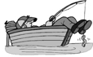
Appendix J: Outdoor Ethics Awards

Go to http://outdoorethics-bsa.org/awards/ for the links to online training videos and to download and print the complete brochure and application.

Awareness Awards (Round Green Patch):
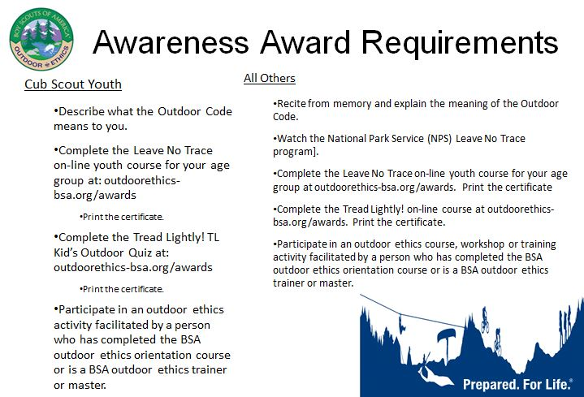

Action Awards (Name Tags with emblem device)

Cub Scouts Action Award:

Currently under construction due to a new adventure

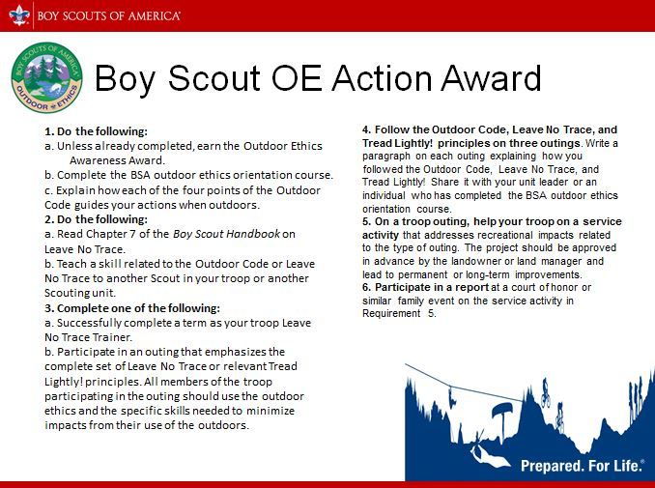

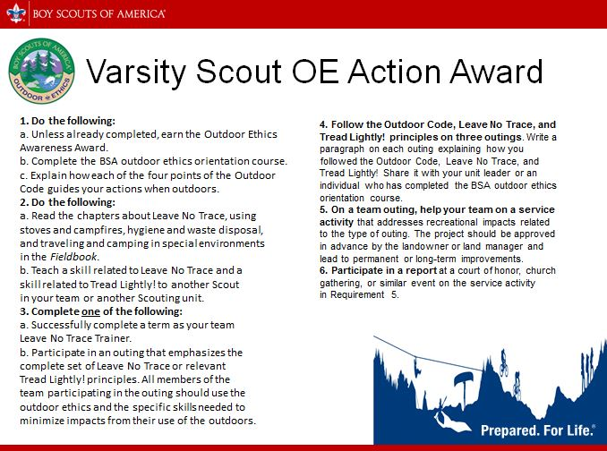

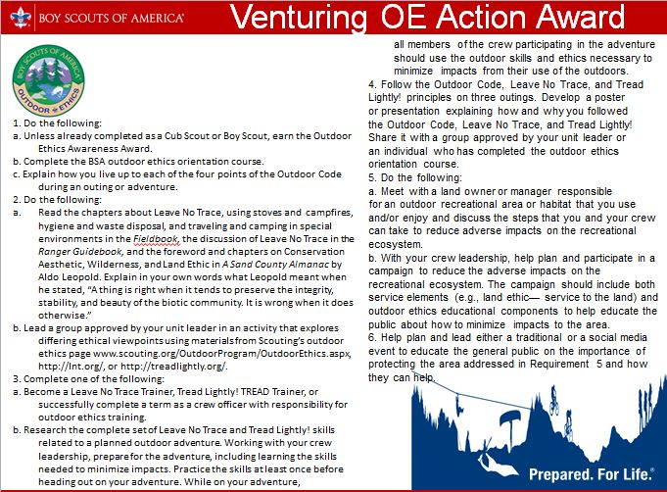


BSA Outdoor Ethics Summary
Cub Scout, Boy Scout, Varsity Scout, Venturing, and Sea Scout programs all include outdoor stewardship, care for the environment, and Leave No Trace as part of their programs.

Outdoor Code
As an American, I will do my best to -
1/ Be Clean in my outdoor manners
2/ Be Careful with fire
3/ Be Considerate in the outdoors
4/ Be Conservation minded

“The land ethic simply enlarges the boundaries of the community to include soils, waters, plants, and animals, or collectively: the land.” Aldo Leopold A Sand County Almanac

Leave No Trace is an international program designed to assist anyone who spends time outdoors with their decisions about how to reduce their impacts when they hike, camp, picnic, snowshoe, run, bike, hunt, paddle, ride horses, fish, ski or climb. The program strives to educate all those who enjoy the outdoors about the nature of their recreational impacts as well as techniques to prevent and minimize such impacts. Leave No Trace is an educational about ethical choices and decisions, not as a set of rules and regulations. Leave No Trace information is rooted in both scientific studies and common sense.

Seven Principles of Leave No Trace Leave No Trace Principles for Kids
1/ Plan Ahead and Prepare 1/ Know Before You Go
2/ Travel and Camp on Durable Surface 2/ Choose The Right Path
3/ Dispose of Waste Properly 3/ Trash Your Trash
4/ Leave What You Find 4/ Leave What You Find
5/ Minimize Campfire Impacts 5/ Be Careful With Fire
6/ Respect Wildlife 6/ Respect Wildlife
7/ Be Considerate of Other Visitors 7/ Be Kind To Other Visitors

Tread Lightly! promotes responsible outdoor recreation through ethics education and stewardship programs which focus on motorized and mechanized recreation including mountain biking, ATV riding, personal watercraft, and others.

1/ Travel Responsibly
2/ Respect the Rights of Others
3/ Educate Yourself
4/ Avoid Sensitive Areas
5/ Do Your Part
How to get more information and additional training:

BSA Outdoor Ethics Programs:

Read more about the Outdoor Ethics Awards program and Leave No Trace in advancement, and find additional training resources. Also find out about upcoming Leave No Trace and Tread Lightly! training courses here:
http://www.outdoorethics-bsa.org

Leave No Trace Center for Outdoor Ethics: teaches people how to enjoy the outdoors responsibly. The seven Leave No Trace principles are copyrighted and should be used together as a system for ethical decision making in the outdoors. More information is available on their site:
http://lnt.org/

Tread Lightly! promotes responsible recreation where lands and waters are protected, safety is a top priority and everyone enjoys the experience of being outdoors.
http://treadlightly.org

Training Courses:

-Leave No Trace Awareness: An online course or short presentation that introduces participants to the 7 principles of Leave No Trace
-BSA Leave No Trace 101: A 4 hour course that is the minimum recommended training for ALL adults who will be teaching and/or signing off on the Leave No Trace requirements for rank and badges.
-Leave No Trace Trainer course: A 16 hour course, typically offered in a weekend format, which focuses on teaching techniques for sharing information about Leave No Trace. The course includes an opportunity for each participant to teach a Leave No Trace lesson. This course is required for Scouts who seek to be appointed to the Troop Leave No Trace Trainer position of responsibility.
-Leave No Trace Master Educator course: This 5+ day course includes in depth discussion of the Leave No Trace principles and their application, along with guidance and practice in teaching Leave No Trace to various audiences, and instruction in conducting Leave No Trace Trainer courses. The Master Educator course includes a three night field experience for practicing Leave No Trace principles. The course is open to any Scout leaders or Venturers age 18 or older.

-Tread! Awareness: An online course or short presentation that introduces participants to the 5 principles of TREAD Lightly!
-Tread Trainer: an 8-hour training course provided by a current Master Trainer which qualifies the participants to present Tread Lightly! Awareness courses and promote Tread Lightly! at events.
-Tread Master Trainer: 16-hour provided by a TL! center certified Master Trainer which qualifies the participants to teach Tread Lightly! Trainer courses, awareness and promote Tread Lightly! at events.

If you have other questions or want information about Leave No Trace or Outdoor Ethics training, please contact:
(Grand Tetons Council) Bonny Jennings @ 208-589-3149 or Bonny.Jennings@HCAHealthcare.com
(Great Salt Lake Council) Matt Durrant @ 208-851-1587 or lnt.gslc@gmail.com
(Trapper Trails Council) Leroy Wilson @ 801-867-2059 or lawilson@dsdmail.net
(Trapper Trails Council) Mike Adams @ 307-679-1433 or cradams@allwest.net
(Utah National Parks Council) Keith Abraham @ 801-971-8060 or keith.abraham@comcast.net
The Web of Life

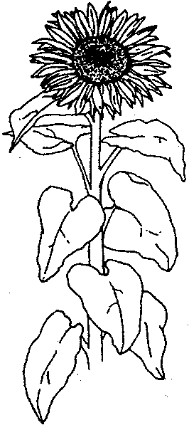
Overview
Students construct a food web to learn how all living things in an ecosystem are interconnected and energy for life comes from the sun.

Suggested Grade Level
PreK - 1

Estimated Time
30 - 40 minutes

Objectives
Students will be able to:

1. show how plants and animals get energy, by telling other students which plants and animals are eaten by other animals.
2. explain that energy for life comes from the sun.
3. explain how all living things depend directly or indirectly on green plants for food.
4. use pictures and arrows to create a food web that includes the sun, green plants, and animals from the prairie.

Materials
1. Ball of yarn
2. Pictures of prairie plants, animals, and humans
3. Tape to attach pictures to clothing
4. Space for the class to form a large circleThe Sun is the Source

Food Chains

The above diagram illustrates a food chain that might be found in the prairie.
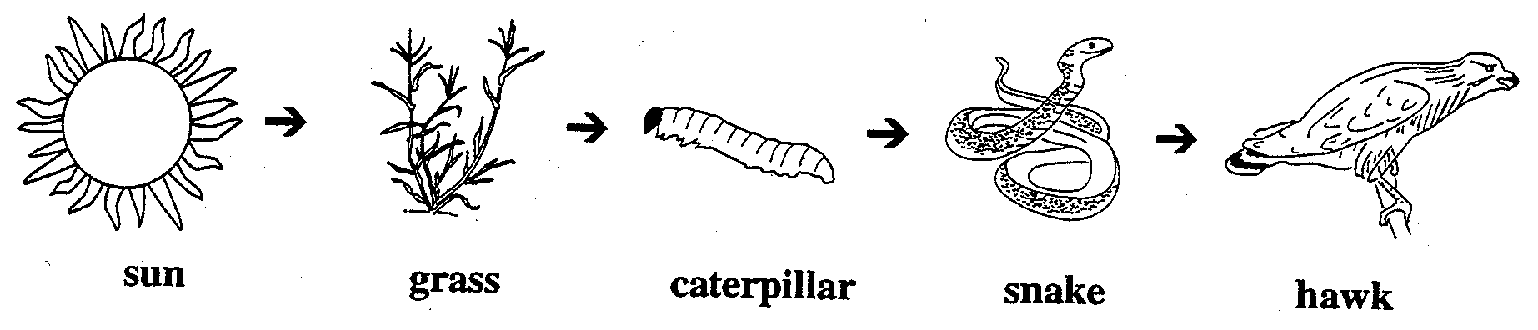

Food Webs

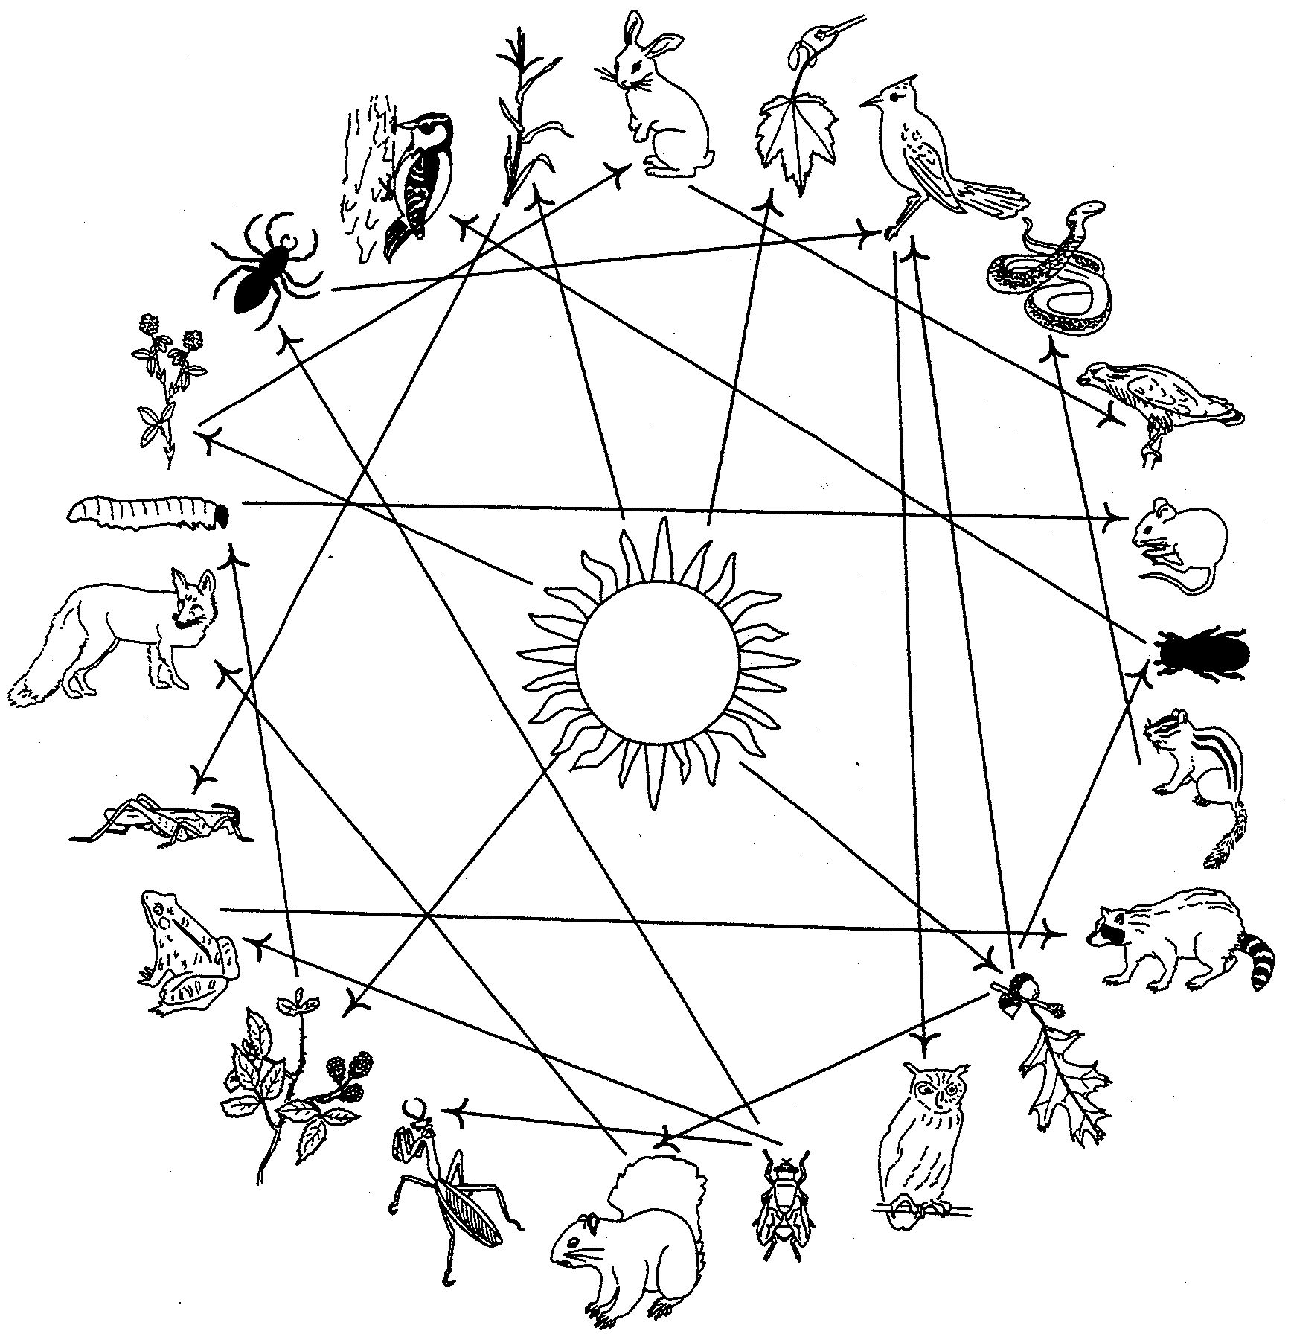

Activity
1. Copy, cut and pass one picture of prairie plants and animals to each student.
Be sure that there are enough plant species represented.

2. Tell the students that they will see how plants and animals are all interconnected in the prairie and other ecosystems. Have them sit in a circle and introduce themselves as the plant or animal they represent.
3. Hold the end of the yarn tightly and toss the ball to someone who can use that energy (a green plant). When a student representing the green plant catches the ball of yarn, he or she should hold the yarn and throw the ball to someone else who could use the energy (an animal that might eat them). For example, the sun might throw the yarn to the grass, the grass to the grasshopper, and the grasshopper to the quail. Each time have the students hold tightly to the loop of yarn. Next have students throw the ball of yarn to someone that either they give energy to or they get energy from. The quail could throw the yarn to the fox (someone who takes energy from them; eats them) or to the caterpillar (someone they get energy from; something they eat). NOTE: Most of the action will take place between the plants, the sun and the herbivores (animals that eat plants) It takes many energy transfers to get to the carnivores (animals that eat other animals).

After the ball of yarn has been passed to everyone at least once, and the plants and the sun many times, explain that you have created a food web (it looks like a spider’s web). This is a graphic way to show how plants and animals are interrelated in a community.

Ask:
Who is holding the most yarn? (The sun.)

Who else is holding many loops of yarn? (Green plants.)

What would happen if all the green plants died? (There would be no food. Nothing else in the food web could survive.)

What would happen if one kind of plant, such as all the clover, died? (The student representing clover could drop the yarn and the food web would sag and be less complex.)

If all the clover was gone, who else may have trouble getting enough food? Who gets their energy from the clover? (Look at the sagging parts of the web to see who was holding pieces that are connected to the
clover)

Why should we be concerned about each kind of plant or animal? (Because other plants and animals in the food web may depend on them. We are all connected.)

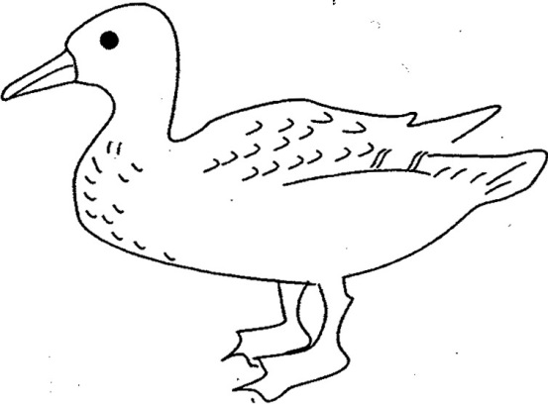
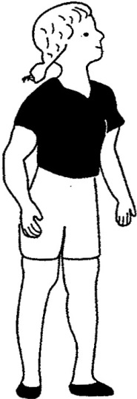

Human Duck

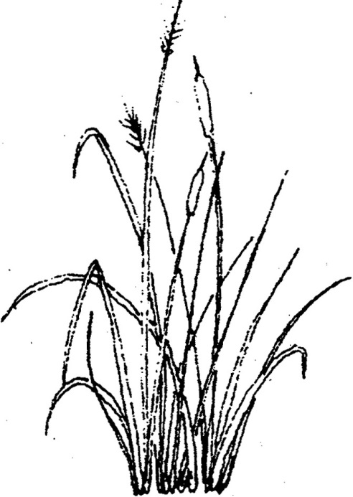

Prairie Grass

._,;; 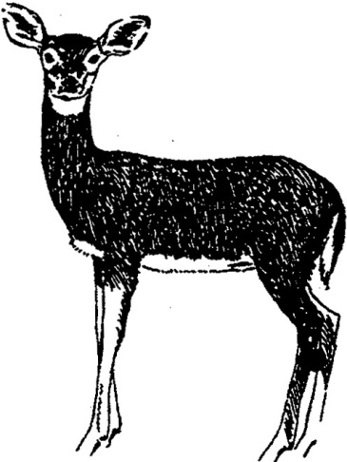

Deer

USDA-Au in the Classroom-www.auclassroom.org
Web olUle-Grades PreK-1:S-1

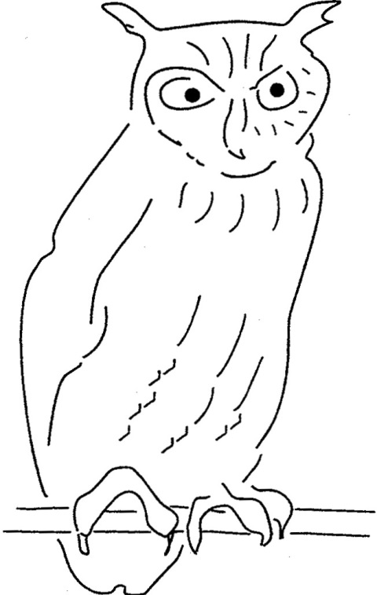  Owl | 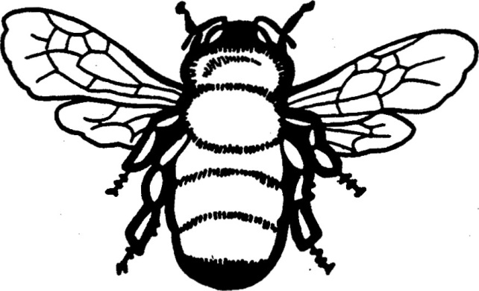  Bee
  Mole | 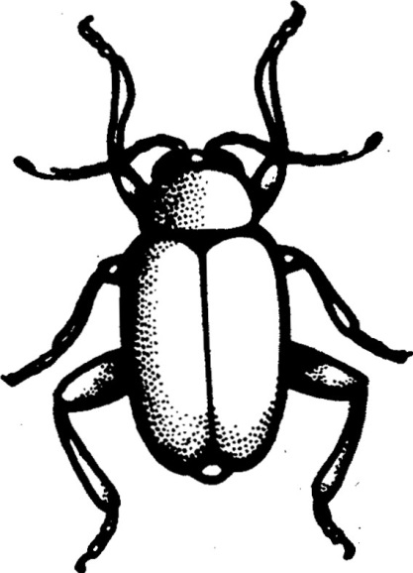  Beetle

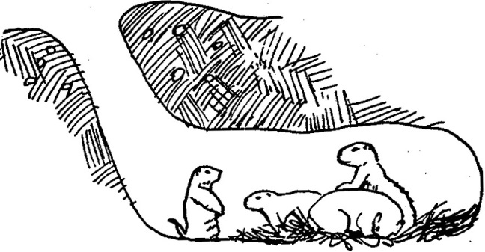  Prairie Dogs | 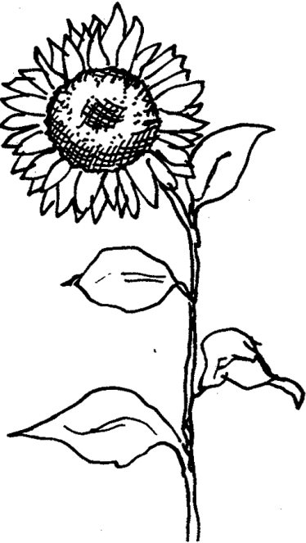  Sunflower
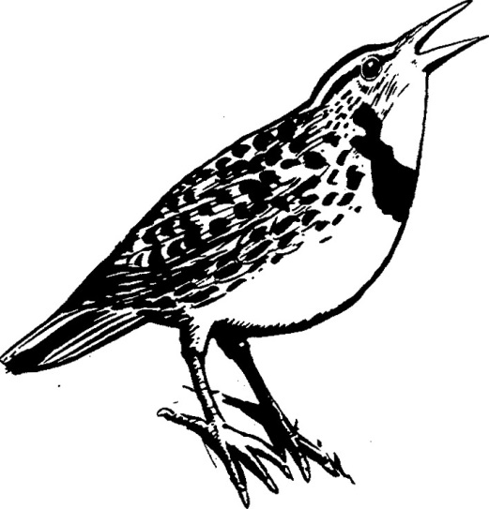  Meadow lark |   Quail

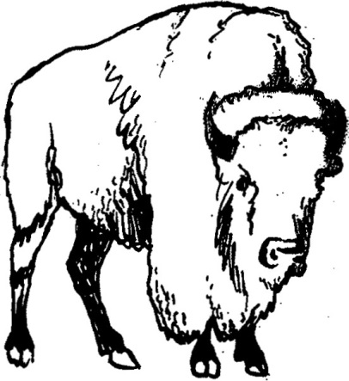

Bison


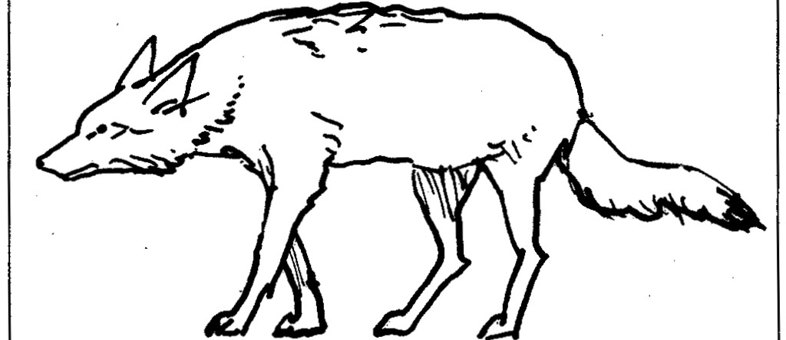

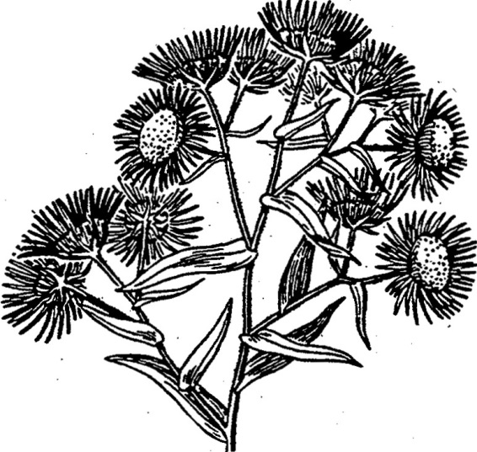

Aster

Butterfly

Coyote

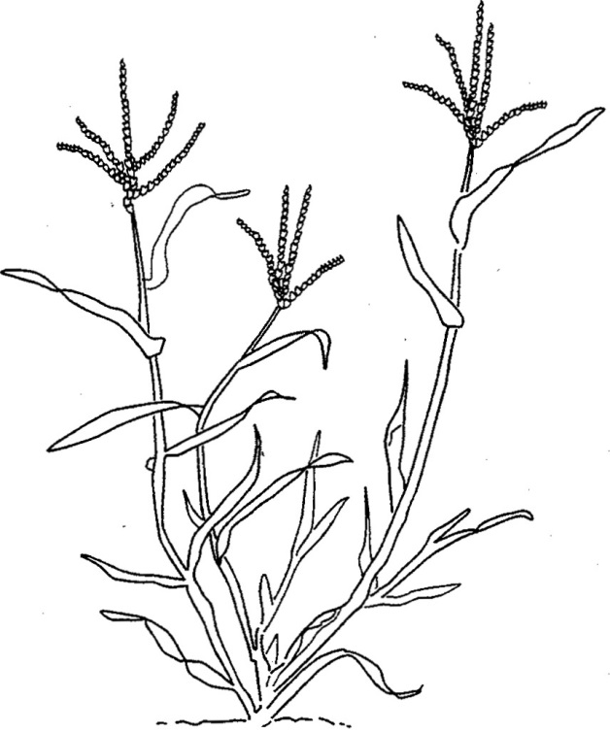

Sun



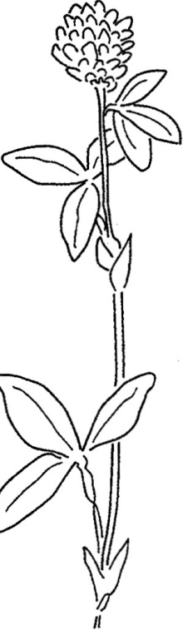
Clover
Orchard grass

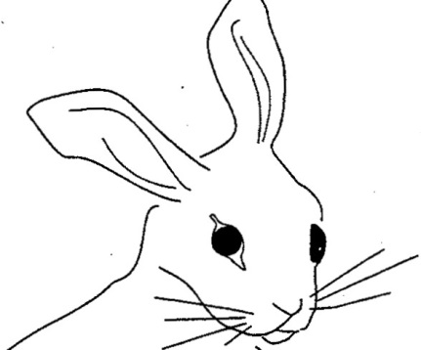

. Rabbit

The Web of Life Activity Sheet 6
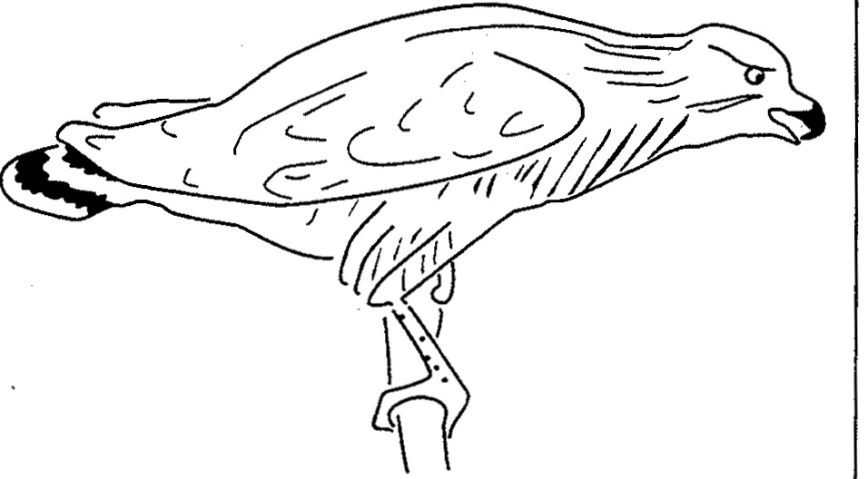



Spider Hawk

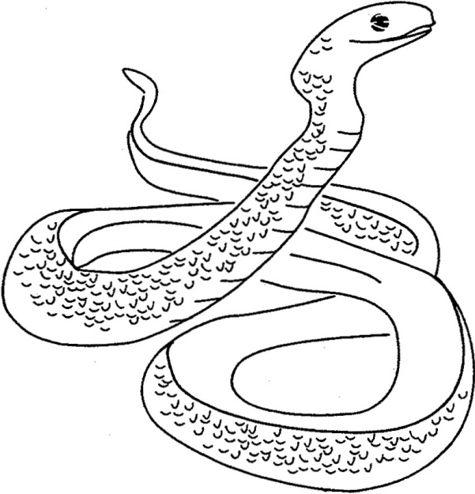
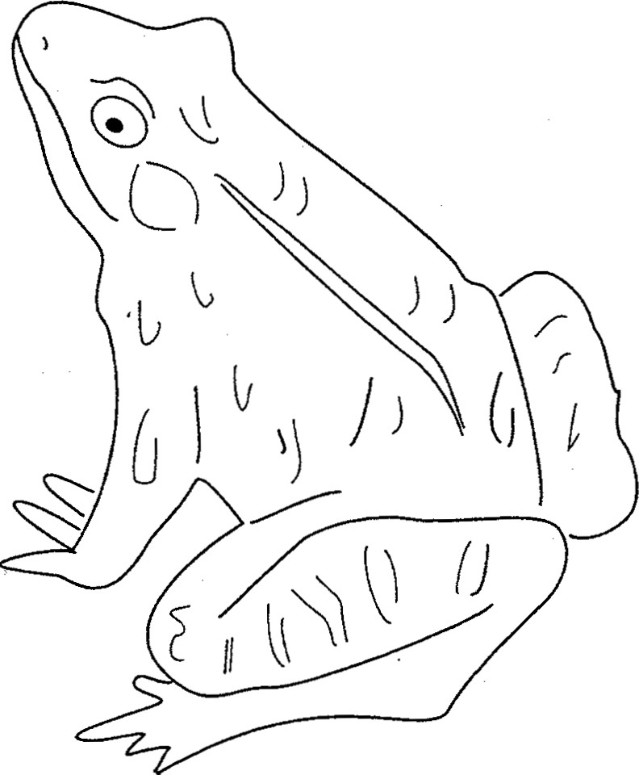

Snake Frog

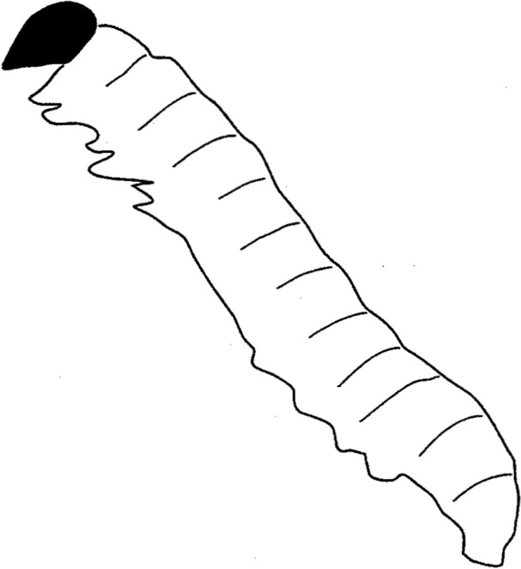  Caterpillar | 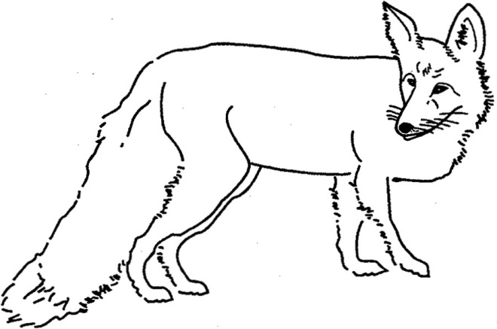  Fox
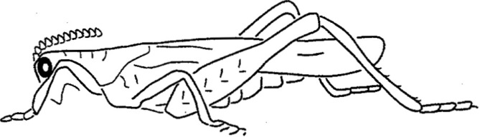  Grasshopper | 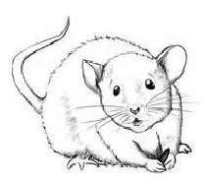  Mouse

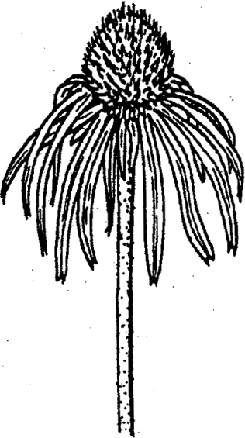  Coneflower | 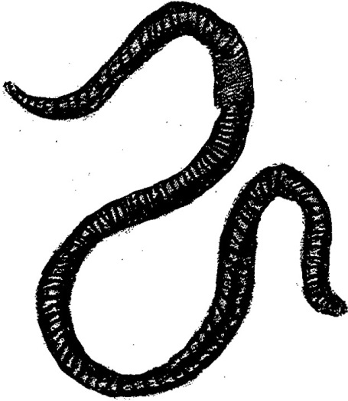  Worm
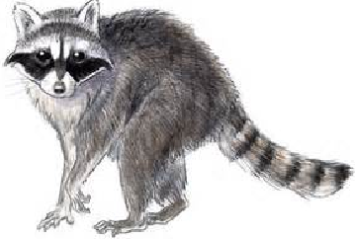  Raccoon |   Black-eyed Susan

Outdoor Ethics Orientation Evaluation
Date____________________Location_____________________

Please rate the following on a scale of 1-5, 1 being poor and 5 being excellent.
-Were the instructors knowledgeable of the topic? 1 2 3 4 5
Comments:

-Were the course objectives met? 1 2 3 4 5

Comments:

-Do you have a better understanding of Outdoor Ethics
and its relationship to the BSA Outdoor Code? 1 2 3 4 5
Comments:

-Do you understand how the Leave No Trace, Tread Lightly!
and the Land Ethic support the BSA Outdoor Code. 1 2 3 4 5
Comments:

-Will you be able to assist your unit and others to earn
the Outdoor Ethics Awareness and Action Awards? 1 2 3 4 5
Comments:

-Do you know where to get more information? 1 2 3 4 5
Comments:

-Do you know where to get further training? 1 2 3 4 5
Comments:

-Are you interested in future training? Yes No

Name e-mail

