2016 BSA Outdoor Ethics National Conference
Name: Dave Whittekiend
Home Base: Uinta-Wasatch-Cache National Forest
Personal Info, Education, Job, etc:
I am 2nd generation Forest Service and grew up moving from one western town to the next. I received a B.S. in wildlife biology from Colorado State and a M.S. in botany from BYU. My career with the Forest Service started in 1988 as a seasonal range technician on the North Kaibab Ranger District, AZ. My first permanent appointment was a wildlife biologist on the Teasdale Ranger District, Dixie National Forest, UT. From there I went to the Lewis and Clark National Forest, MT, where I worked on the Rocky Mountain Ranger District as the wildlife, timber and minerals staff. While on the Lewis and Clark I also held positions as a team leader for a mineral withdrawal and acting District Ranger on the Kings Hill Ranger District. I also served as District Ranger on the Soda Springs Ranger District, Caribou-Targhee National Forest, ID. After being a District Ranger, I worked in the Forest Service Nation Headquarters in Washington D.C. on the forest plan appeals and legislative affairs staffs.
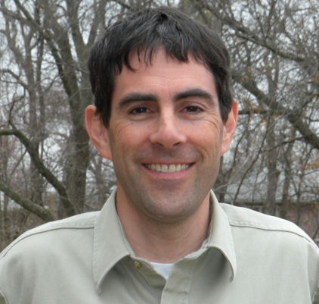
I am currently the Forest Supervisor on the Uinta-Wasatch-Cache National Forest. Prior to moving to Utah, I was the Forest Supervisor of the Mark Twain National Forest in Missouri. I live in Herriman with my wife and four kids (one son and three daughters). I enjoy being outdoors and doing outdoors things such as fly fishing, mountain biking, camping and adventure racing.

