2016 BSA Outdoor Ethics National Conference
Name: John Gonering
Home Base: San Bernardino, CA

Some things you should know about me: I am a single parent raising 3 children. One has moved out of the house to be closer to his school, my alma mater the University of California, Irvine. The other 2 are still at home and keep me busy and are active in Leave No Trace. I have been a software engineer for nearly 40 years. I have worked for different companies in 3 different states and 3 different countries. I can speak 3 different flavors of English – American, Australian and British. I have been an Assistant Joey Scout and Assistant Cub Scout Leader – DYB, DYB, DYB, DOB, DOB, DOB. I am old enough to have been a member of Knights of Dunamis (the predecessor to NESA.)

Vital Statistics: I hail from Long Beach, CA. I earned the rank of Eagle shortly before my 16th birthday. I was active in both the Knights of Dunamis and the Tribe of Tahquitz (we did not have OA in my council.) I was awarded the Knight Eagle from the Knights as well as the Silver Wreath from NESA.
I worked my way through college at the typical Southern California jobs, first as a lifeguard, then at Disneyland.
After 30 some odd years of living there, I started my travels of job relocation. I’ve lived in Colorado, where my sons were born. After a while, we moved to New Mexico, the Land of Enchantment. From there we moved from on desert to another, the Simpson Desert in the Outback of Australia. This is where my daughter was born. In the Outback I learned of the Traditional Landowners’ philosophy of nature which embodies the principles of Leave No Trace and the Land Ethic.

History with BSA and Leave No Trace (insert pictures/selfies as necessary):
In 2010, my sons and I moved to the Inland Empire. One of my sons was looking to get involved with Scouting again. He found the Master’s course and encouraged me to take it. After that, I’ve been either leading or assisting on Trainer courses. After my daughter moved in with me, she started attending Trainer courses to past the time. She eventually became a Trainer. A couple of years ago I was asked to take over as the Area 4 OE Advocate. I’m working with councils in my area to get an OE program. We’ve organized a cadre of Masters and Trainers to travel to other councils to put on courses.
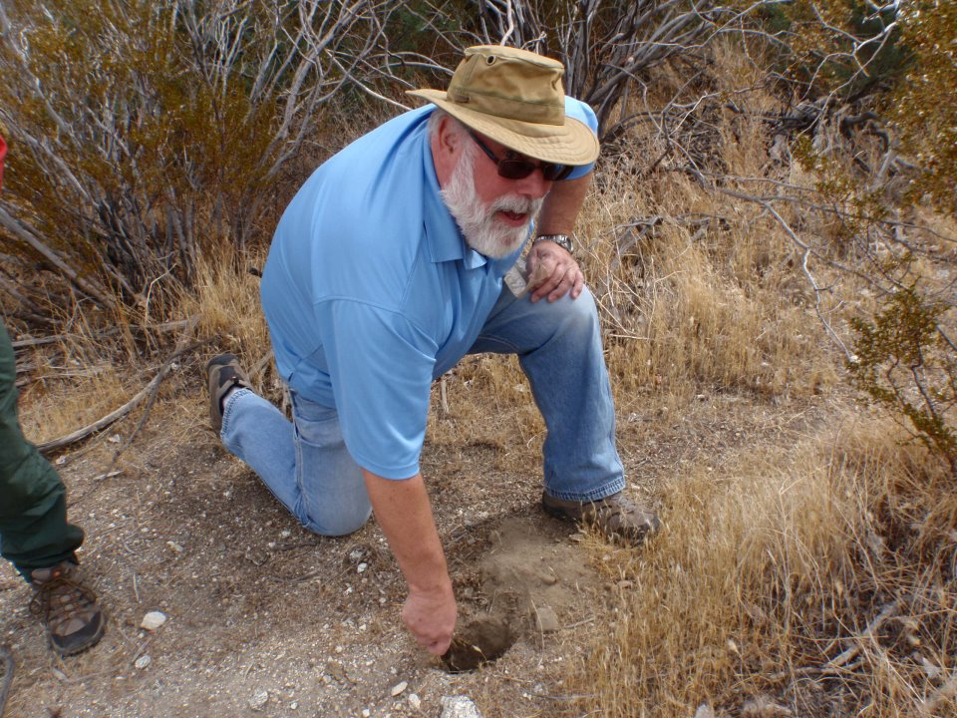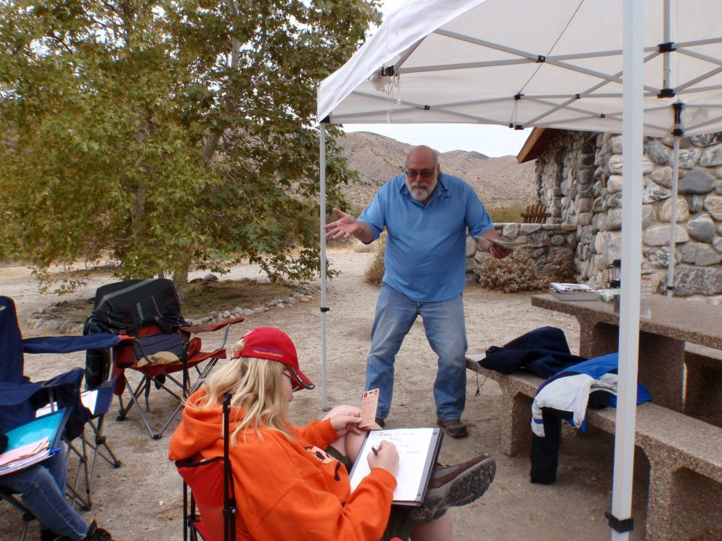

Involvement with BSA: In addition to Outdoor Ethics, I am involved in youth leadership development. I have been on NYLT staff multiple times, until I “aged out.” In my younger days, I participated in the transition of the Knights of Dunamis to the National Eagle Scout Association. As a result of my scouting career both here and abroad, I have been awarded the Silver Beaver. Last year I became a BSA Certified Angling Instructor.

Other Outdoor Activities and Interests (insert pictures/selfies as necessary):
I still enjoy camping and fishing. Although I don’t get to do either enough. My job requires me to travel internationally. While on my travels I get to explore many natural and historic places of interest. When I travel, I take hang tags as I never know with whom I can share Leave No Trace.

